**Early Modern Thames Maphackathon, February 11th-12th, 2014**

**Quayside room, Museum of London Docklands**

**Royal Museums of Greenwich maps of interest**

**Charts and maps[1]**

You can download up to 25 images for free, for non-commercial use. See our [terms and conditions](http://collections.rmg.co.uk/page/7d7ded6fb50d6031e2884961a200c297.html) for more details.   
Read more at <http://collections.rmg.co.uk/collections/objects/542339.html#qQYMD7CIVqBOSxOI.99>

**http://collections.rmg.co.uk/collections/objects/542738.html**

SEARCH: “Thames”, filter by “Charts & Maps”

“Thames” unfiltered = 1935 matches

Object ID: GREN HWD E6 [Part 6]  
Description: Edition: 1st edn. Single sheet. Hand col. engr. Medium: Two original sheets have been mounted together, segmented and backed. Scale: 1:2 437 (26 inches to the mile). Additional Places: Rotherhithe, Poplar. Contents Note: The yards fronting the Thames are identified by their owners' names, There is a key to the different types of buildings and a note on house numbering on sheet E8.

Date made: 1793

Artist/Maker: Horwood, Richard

Place made: London

Credit: NMM

Materials: Paper

Measurements: 56 cm x 103 cm

Collection: Charts and maps

<http://collections.rmg.co.uk/collections/objects/542339.html>

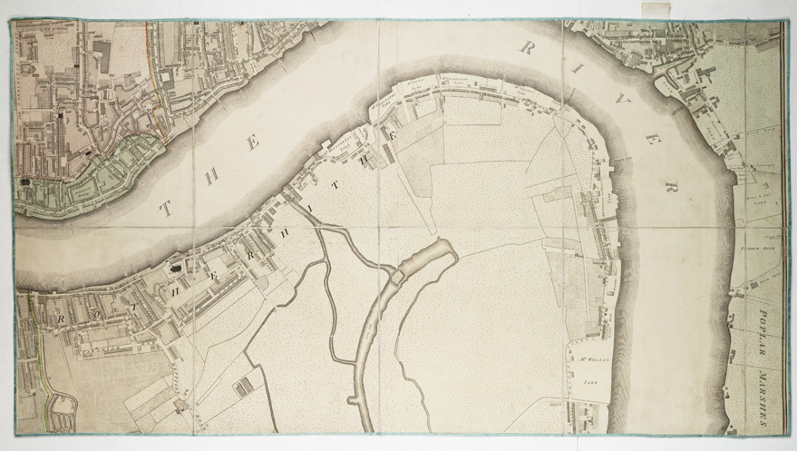

Sheet 8 (Deptford) from the east half of the: 'Plan of the cities of London and Westminster, the borough of Southwark and parts adjoining shewing every house' to a Collection  
<http://collections.rmg.co.uk/collections/objects/542341.html>

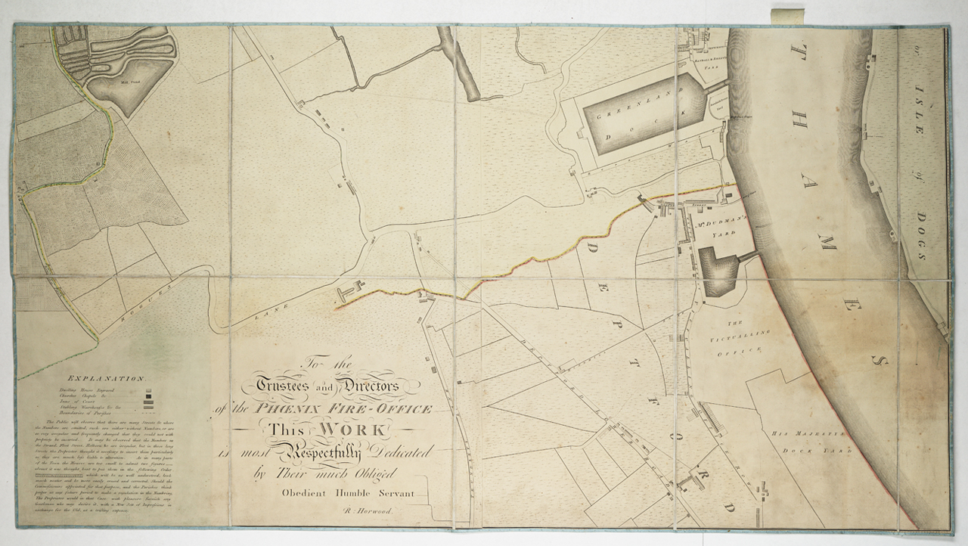

Mr Ogles Plan for Mooring Vessels in the River Thames from London Bridge to Deptford  
<http://collections.rmg.co.uk/collections/objects/209108.html>

Object ID: Z BA1436

Description: Colour, printed map of the River Thames, from London Bridge to Deptford. Showing Ogle's proposal for new berthing arrangements by port of origin/destination and type of commodity. Published by John Fairburn of The Minories, London  
Date made: 1796:

Place made: London, UK

Credit, NMM

Measurements: 325 x 500 mm

Parts: Mr Ogles Plan for Mooring Vessels in the River Thames from London Bridge to Deptford (ZBA1436)  
Collection: Charts and maps

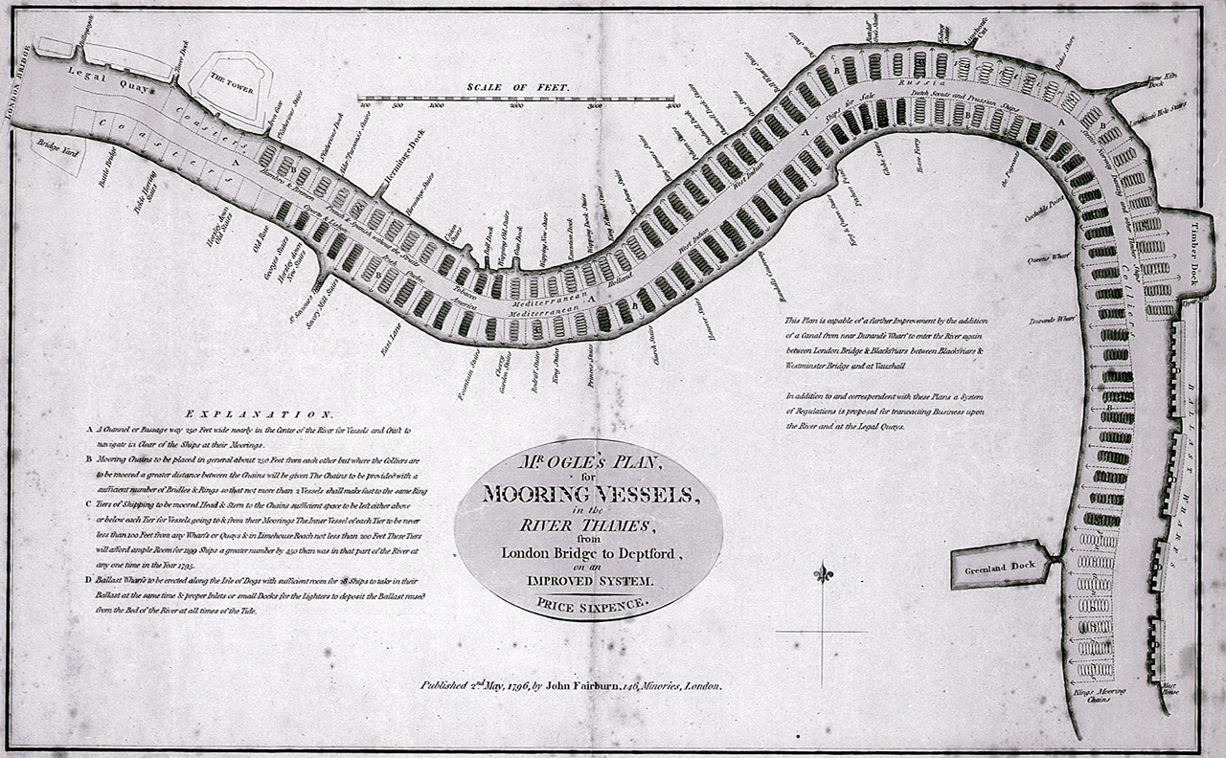

Title: A late survey by John Diston of Lowestoff, pilot, master & mariner [River Thames from London Bridge to the Isle of Dogs]

<http://collections.rmg.co.uk/collections/objects/542738.html>

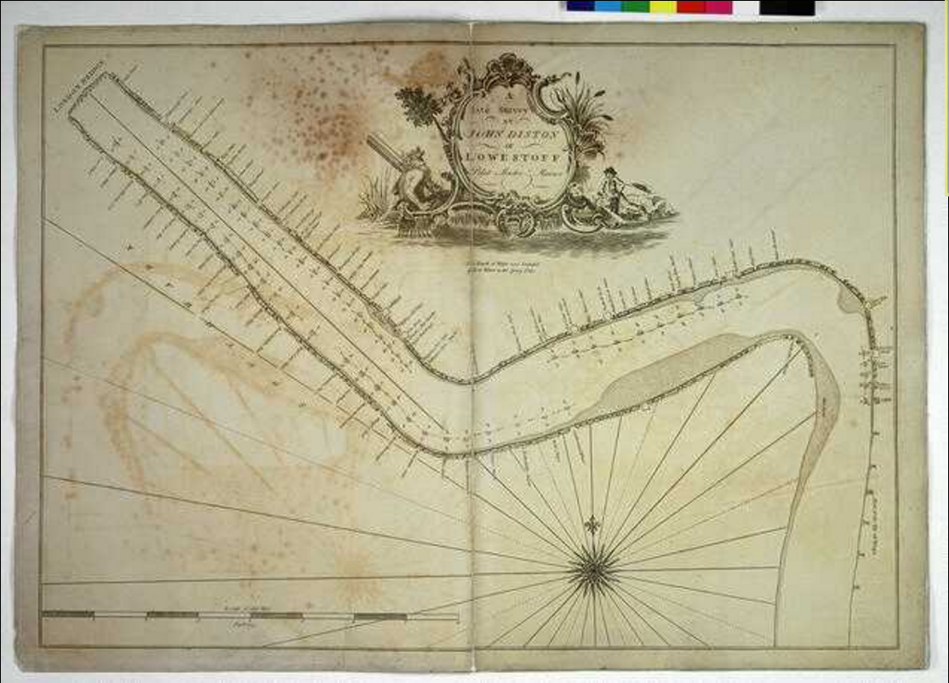

Object ISL DISO1(1)

Description: Bound sheet, engraving. Scale: [circa 1: ]. Bar scale of one mile in furlongs. The chart depicts and identifies wharves, stairs, docks, warehouses and other shoreside features and shows anchorages. The cartouche is decorated with Father Thames and a boy fishing with a hand-line.

Date made: 1797

Artist/maker: [Diston, John](http://collections.rmg.co.uk/collections.html#!csearch;authority=agent-177053;browseBy=maker;makerFacetLetter=D)  
[Robert Sayer & Co](http://collections.rmg.co.uk/collections.html#!csearch;authority=agent-177054;browseBy=maker;makerFacetLetter=R)  
Place made: London

Credit: NMM

Measurements: Printed area 50 x 70.5cm, on sheet 53 x 75cm

Parts: A late survey by John Diston of Lowestoff, pilot, master & mariner [River Thames from London Bridge to the Isle of Dogs] (DIS01(1))  
  
TITLE: A new and correct chart from the Isle of Dogs, to Prittlewell, and the Nore

<http://collections.rmg.co.uk/collections/objects/542739.html>

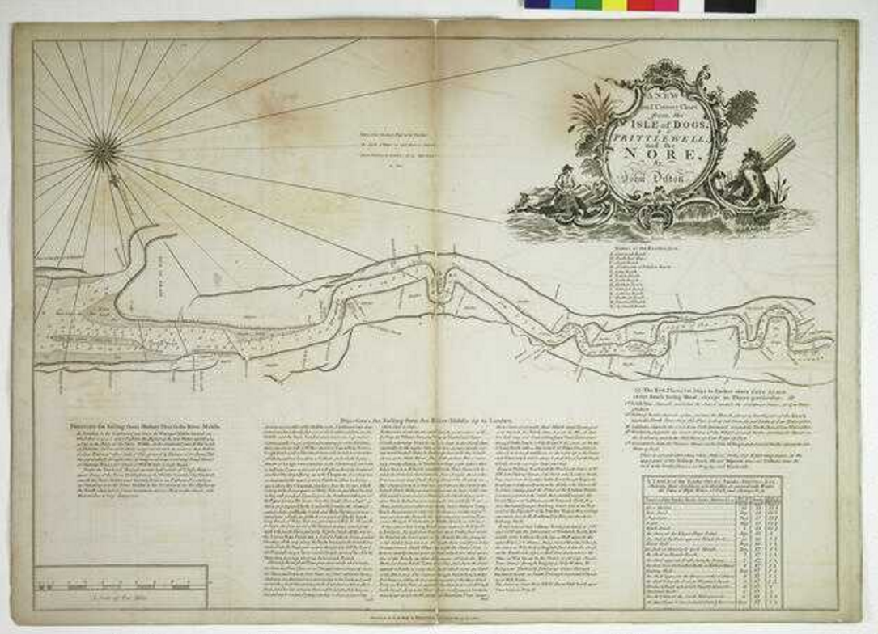

Object ID: DIS01(2)

Description: Bound sheet, engraving. Scale: [circa 1: ]. Bar scale in miles. North at 159 degrees (magnetic). Contains sailing directions, a list of the best places for ships to anchor and a table of shallows. The cartouche is decorated with Father Thames and a boy fishing with a hand-line.  
Date made: 1797

Artist/Maker: [James Whittle & Richard Holmes Laurie](http://collections.rmg.co.uk/collections.html#!csearch;authority=agent-160192;browseBy=maker;makerFacetLetter=J)  
[Diston, John](http://collections.rmg.co.uk/collections.html#!csearch;authority=agent-177053;browseBy=maker;makerFacetLetter=D)  
Place made: London

Credit: NMM  
Measurements: Printed area 50.5 x 71cm, on sheet 53 x 75cm

Parts: A new and correct chart from the Isle of Dogs, to Prittlewell, and the Nore (DIS01(2))

TITLE: The Port of London Authority is a public trust for public service and provides every port facility for London's vast imperial and foreign trade

<http://collections.rmg.co.uk/collections/objects/540361.html>

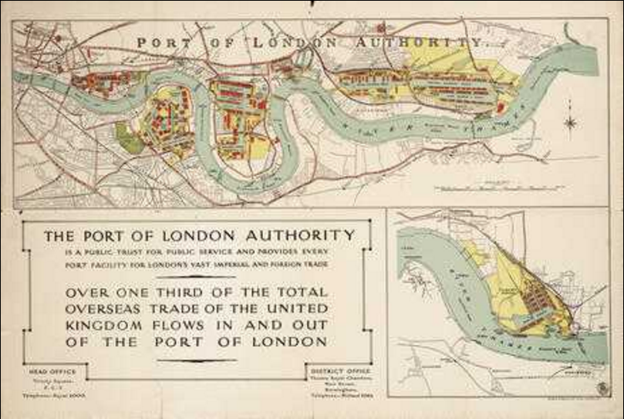

Object ID: G218:9/6

Description: Single sheet, coloured lithograph. Scale [circa 1:15,000 (bar)]. The scale is in feet. This is an ungraduated graphic of the River Thames, shown in two sections: London Bridge to Barking, and Tilbury. Docks, streets and railways are shown. This is a publicity poster, not for navigation

Date made: 1950

Artist/Maker: [Port of London Authority](http://collections.rmg.co.uk/collections.html#!csearch;authority=agent-17493;browseBy=maker;makerFacetLetter=P)  
[Hudson & Kearns Ltd](http://collections.rmg.co.uk/collections.html#!csearch;authority=agent-176329;browseBy=maker;makerFacetLetter=H)  
Place made: London

Credit: NMM

Measurements: Printed area 61 x 96cm, on sheet 67.5 x 100cm  
Parts: The Port of London Authority is a public trust for public service and provides every port facility for London's vast imperial and foreign trade (G218:9/6)

TITLE: [Greenwich to Erith]

<http://collections.rmg.co.uk/collections/objects/540362.html>

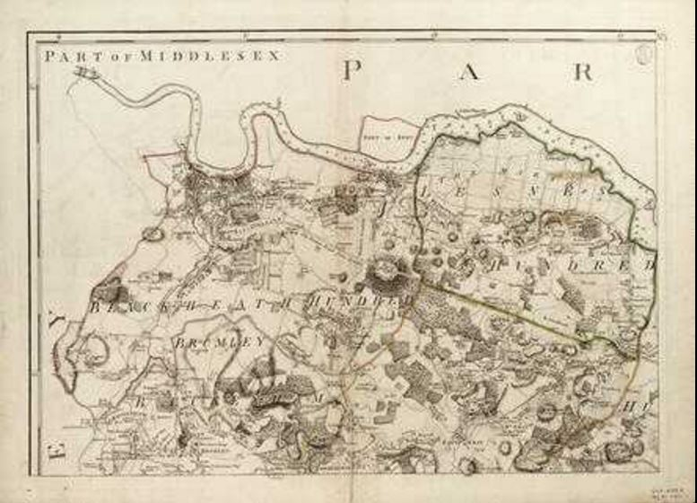

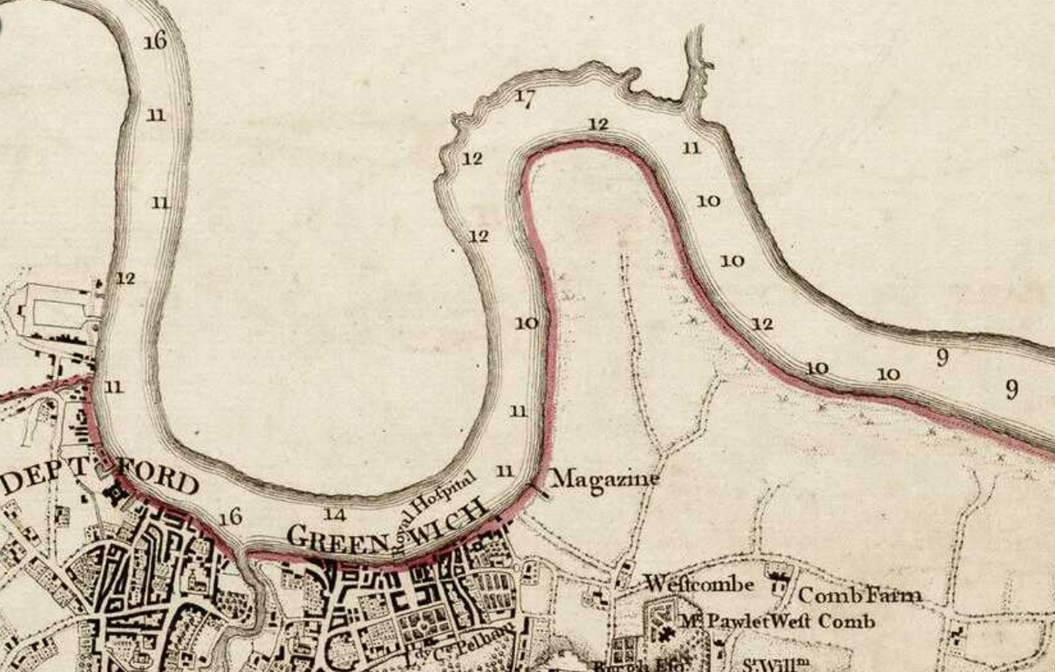

Object ID: G218:8/22C

Description: Single sheet. engraving. Hand coloured in outline, along boundaries. Scale: 1:31,680. The border is graduated for latitude and longitude from the prime meridian of London (not Greenwich). Sandbanks are marked and soundings are given in fathoms. The Thames is decorated with ships. The chart also shows a great deal of land topographical and ownership detail. A sheet from: A topographical map of the County of Kent in twenty five sheets on a scale of two inches to a mile. From an actual survey in which are expressed all the roads, lanes churches, towns, villages, noblemen and gentlemens seats, Roman roads, hills, rivers, woods, cottages and every thing remarkable in the country; together with the division of the lathes and their subdivision into hundreds. By Jn Andrews, Andw Dury and William Herbert  
Date made: 1769

Artist/Maker:  [Andrews, John](http://collections.rmg.co.uk/collections.html#!csearch;authority=agent-165324;browseBy=maker;makerFacetLetter=A)  
[Dury and Herbert](http://collections.rmg.co.uk/collections.html#!csearch;authority=agent-176331;browseBy=maker;makerFacetLetter=D)  
Place made: NMM

Credit:

Measurements: Printed area 46 x 52cm, on sheet 64.5 x 72cm

Parts:

TITLE: East coast of England [Sheet 1/2/3/4] London published by James Imray and Son 89 & 102 Minories 1885

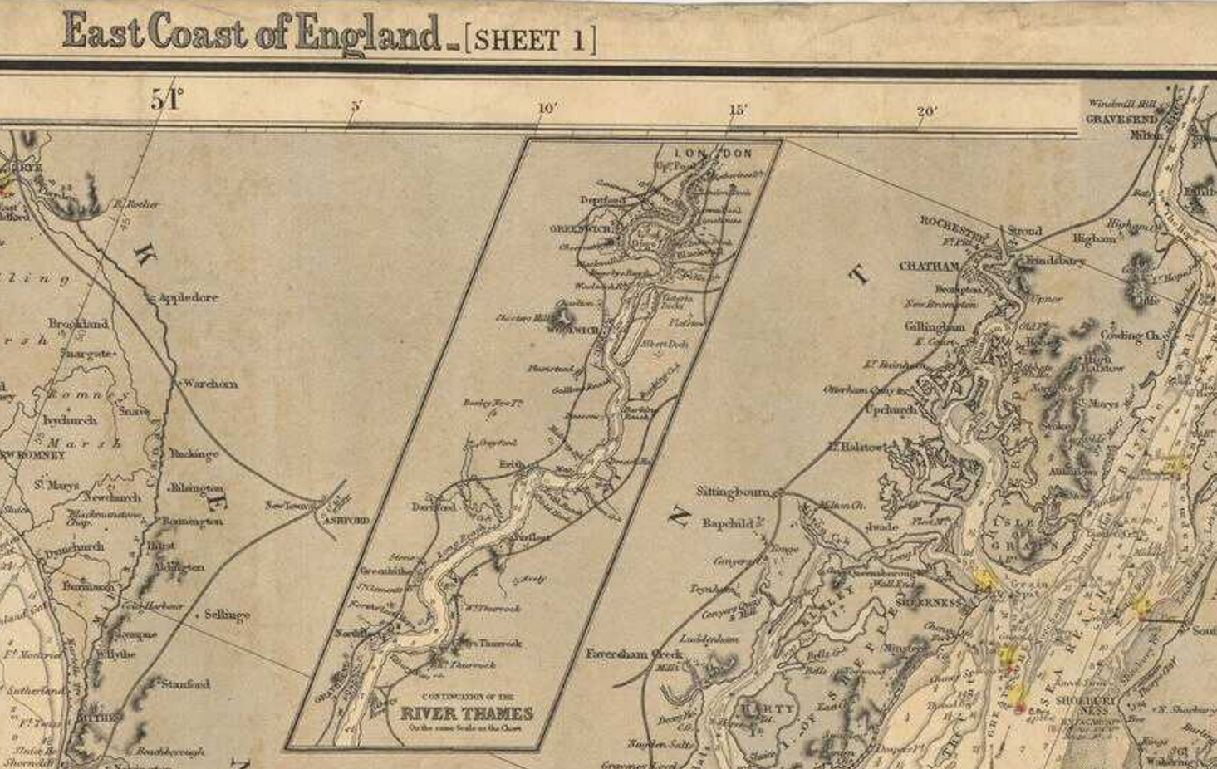

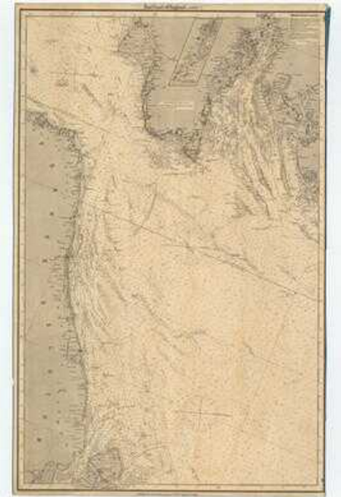

Object ID: G218:11/11

Description: Scale: circa 1:250,000. Printed chart of the North Sea, East coast of England from Dover Straits to the River Tyne. With thirty-two coastal views and ten insets. Shoals and soundings marked. Compass roses with variation. Lights coloured. Blue back. The chart is now in four parts. Insets: Continuation of the River Thames on the same scale as the chart: River Humber 1:80,000 bar; Harwich 1:20,000 bar; Yarmouth and Lowestoft Roads 1:130,000 bar; Bridlington Bay 1:20,000 bar; Sunderland 1:20,000 bar; Whitby 1:20,000 bar; Scarborough 1:30,000 bar; Hartlepool 1:25,000 bar; River Tyne 1:23,000 bar  
Date made: 1885

Artist/Maker: [James Imray & Son](http://collections.rmg.co.uk/collections.html#!csearch;authority=agent-175917;browseBy=maker;makerFacetLetter=J)  
[Imray, James](http://collections.rmg.co.uk/collections.html#!csearch;authority=agent-176519;browseBy=maker;makerFacetLetter=I)  
Place made:   
89 & 102 Minories, London  
Credit: NMM

Measurements:   
Sheet: 255 cm x 104 cm

Parts: East coast of England [Sheet 1/2/3/4] London published by James Imray and Son 89 & 102 Minories 1885 (G218:11/11)

TITLE: Chart of the River Thames from London to the Nore, Margate and the Downs, North, Middle and South Channels, from a survey taken in 1789 and 90Read more at <http://collections.rmg.co.uk/collections/objects/540251.html#ZRTGjqTtzPI8R4oe.99>

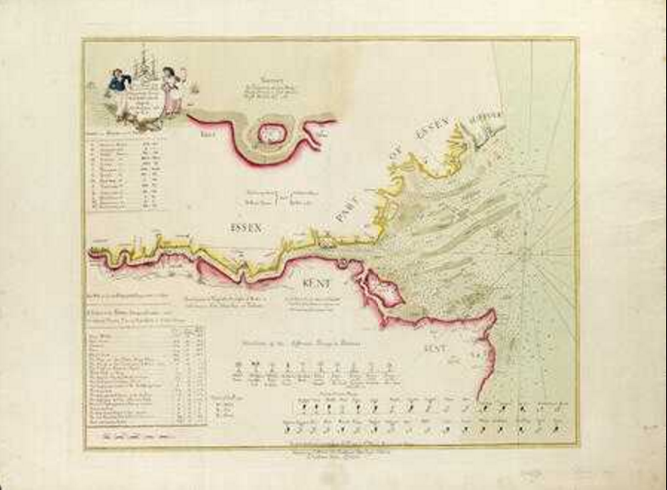

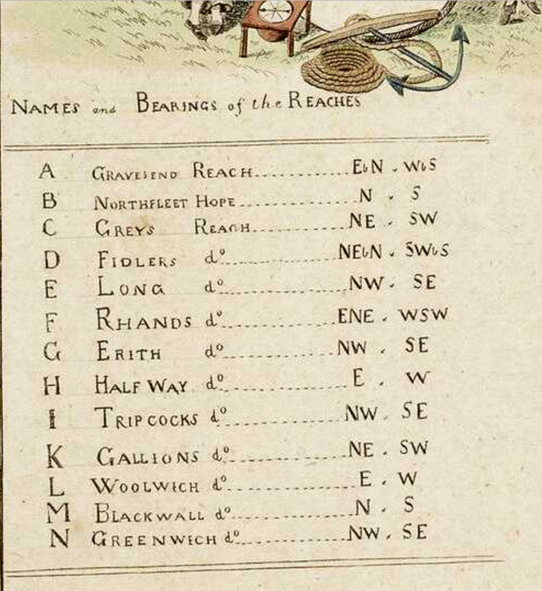

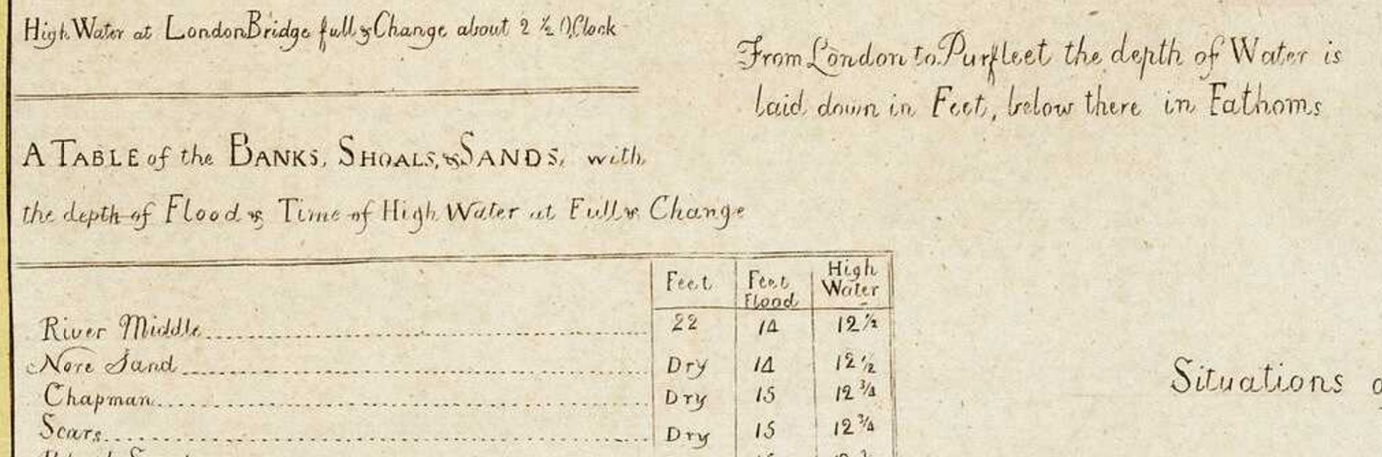

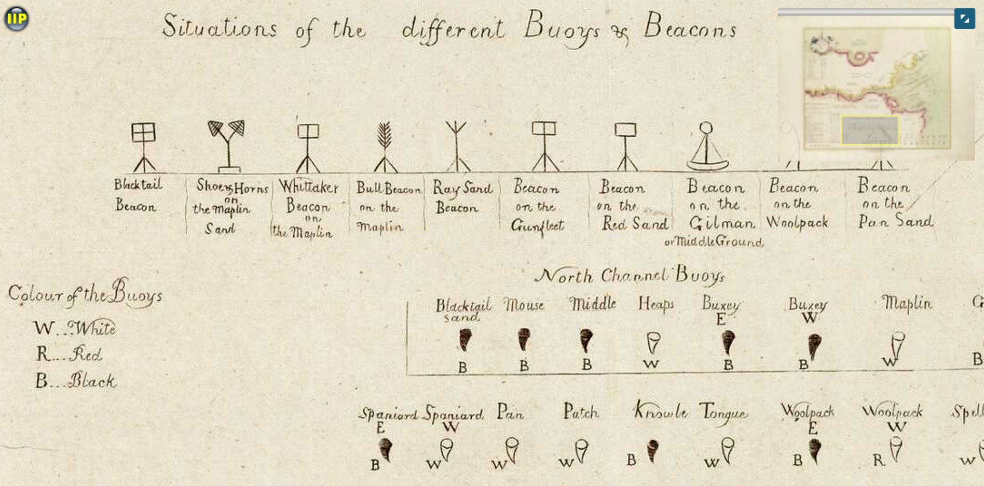

TITLE: To the right Worpll the Master and Wardens of the Trinity House of Deptford Strond this mapp is most humbly dedicatd and presented by Capt Gr. Collins

<http://collections.rmg.co.uk/collections/objects/544154.html>

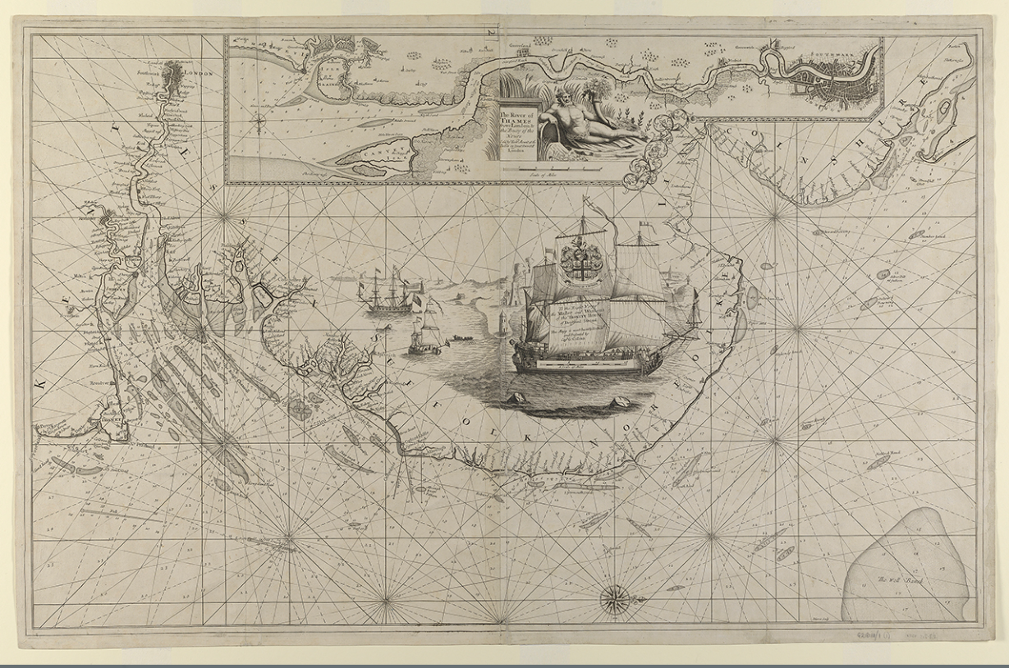

Object ID: G218:11/1(1)

Description: Scale: 1:350,000 (bar). Two copies. Printed chart of the North Sea, Thames Estuary to the Wash. Compass roses and rhumb lines. Shipping scene and elaborate cartouche Insets: The river of Thames from London to the Buoy of the Noure sold by Richd Mount at the Postern on Great Tower Hill 1:120,000 (bar)  
Date made: 1698

Artist/Maker: [Collins, Greenvile](http://collections.rmg.co.uk/collections.html#!csearch;authority=agent-177626;browseBy=maker;makerFacetLetter=C)

Place made: N/A

Credit: NMM

Measurements: Sheet: 96 cm x 67 cm  
Parts: To the right Worpll the Master and Wardens of the Trinity House of Deptford Strond this mapp is most humbly dedicatd and presented by Capt Gr. Collins (G218:11/1(1))

### TITLE: To the right Worpll the Master and Wardens of the Trinity House of Deptford Stroud this mapp is most humbly dedicatd and presented by Capt Gr. Collins

<http://collections.rmg.co.uk/collections/objects/544155.html>

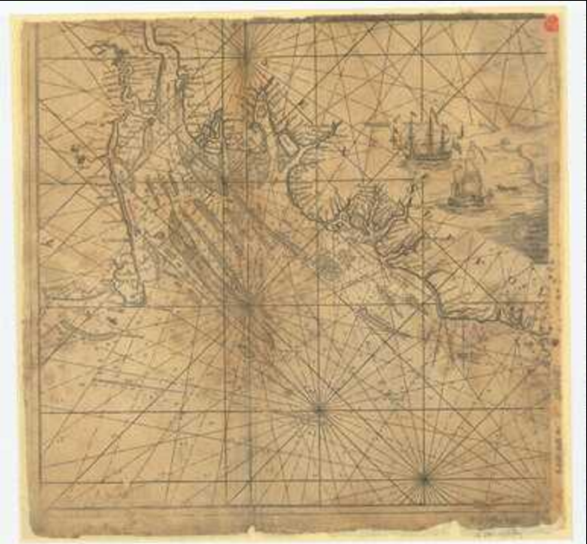

Object ID: G218:11/1(2)A

Description: Scale: 1:350,000 (bar). One of two halves of a printed chart of the North Sea, Thames Estuary to the Wash. This half depicts the Thames Estuary. Compass roses and rhumb lines. Shipping scene and elaborate cartouche. It has been repaired and are on backing sheets.  
Date made: 1698

Artist/Maker: [Collins, Greenvile](http://collections.rmg.co.uk/collections.html#!csearch;authority=agent-177626;browseBy=maker;makerFacetLetter=C)

Place made: N/A

Credit: NMM

Measurements: Overall sheet dimensions: A: 49.5 cm x 47.5 cm  
Parts: To the right Worpll the Master and Wardens of the Trinity House of Deptford Stroud this mapp is most humbly dedicatd and presented by Capt Gr. Collins (G218:11/1(2)A

TITLE: River Thames Wharf chart showing tiers, moorings, etc. between Vauxhall Bridge and Teddington Lock published by Imray, Laurie, Norie & Wilson

<http://collections.rmg.co.uk/collections/objects/544146.html>

Sheet 1. River Thames Wharf chart showing tiers, moorings, etc. between Vauxhall Bridge and Teddington Lock published by Imray, Laurie, Norie & Wilson, Ltd, 123, Minories, London, E.C.3

Object ID: G218:9/76

Description: Scale: circa 1:14,000 (bar). Coloured chart showing the Thames from Vauxhall Bridge to Kew with (inset) a continuation from Kew to Teddington on the same scale. Magnetic variation marked; table of distances; notes on Richmond Lock; notes on tidal variations and river bye-laws. Folded into book form, and backed with cloth.

Date: ca. 1935

Artist: James Imray & Son

Credit: National Maritime Museum, Greenwich, London

Measurements: Sheet: 72 cm x 74.5 cm

Parts: Sheet 1. River Thames Wharf chart showing tiers, moorings, etc. between Vauxhall Bridge and Teddington Lock published by Imray, Laurie, Norie & Wilson, Ltd, 123, Minories, London, E.C.3 (G218:9/76)

1. <http://collections.rmg.co.uk/collections.html#!csearch;collectionReference=subject-90232;authority=subject-90232>